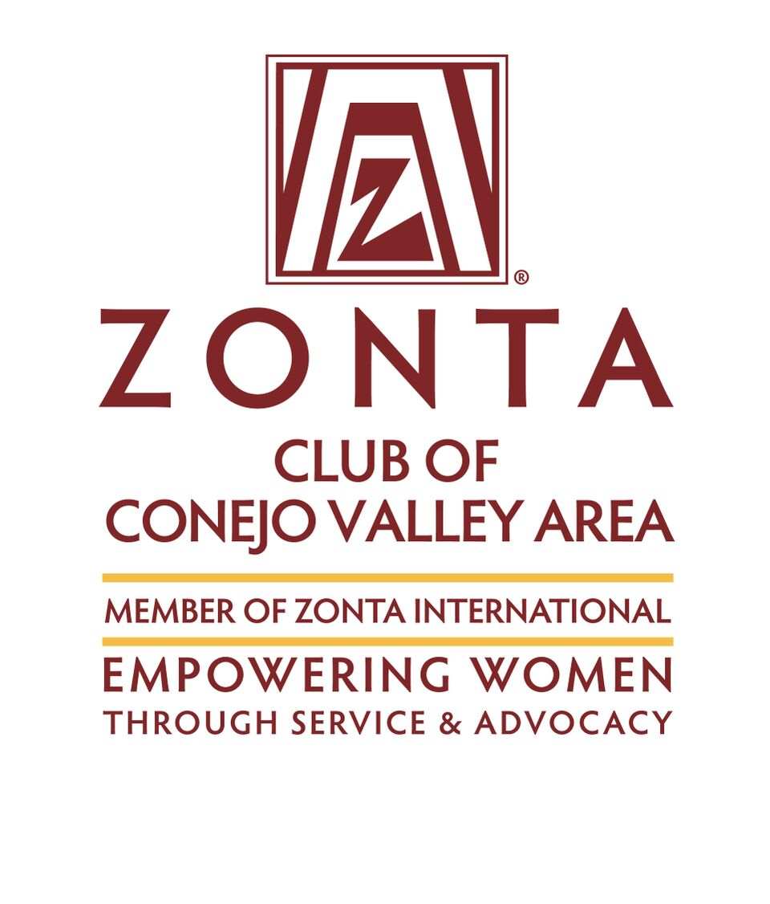Zonta Club of the Conejo Valley Area

P.O. Box 4832, Thousand Oaks, CA. 91359 www.zonta-conejo.org

Submit completed application to: info@zonta-conejo.org
or mail to above post office box.

”Women Helping Women” 2022 Scholarship Application
INCOME

Total Income: $___________/mo. average Current Employer: ___________________________________________

Employer Address: _______________________________________________________________________________

How long? ____________ Employer’s Phone: ________________ E-mail: ________________________________
Position: ___________________________ Hourly / Salary (circle one) Amount: $______________per _________

Do you plan to work while attending college? __________ Number of Hours: _________________

Any Source of Income other than Employment: ________________________________________________________

SCHOOL

School Presently Attending or Will Be Attending: _______________________________________________________
(need Proof of Enrollment)

Degree goal: ______________________________________________________ Years completed: ____________
Highest Prior Degree Received (If any): ______________________________________________________________

Other Scholarships Applied for (note amount if received):________________________________________________

_______________________________________________________________________________________________

APPLICANT

Name: ________________________________________ Date Birth: ________________ Age: ________________

Phone: _______________________________ E-Mail:_________________________________________________

Current Address: ___________________________________ City: ____________________ ZIP: ____________

Own / Rent (Circle) Monthly payment or rent: $_____________

# of Children in Home: _______ # of Adults in Home: (Excluding applicant) _______

Present Childcare Cost & Arrangements: _____________________________________________________________

OTHER INFORMATION Attach pages as needed.

Achievements: Briefly describe any achievements, awards, recognitions or degrees you have received.

Extracurricular & Community Service: Briefly describe your activities on campus and in your community.

Traits: What words would a friend use to describe your outstanding traits?

Goals & Aspirations: Describe your aspirations and goals and how this scholarship will assist you. What do you hope to be doing in five years from now?

Signature: ________________________________________________ Date:__________

